**NTHABISENG CATHERINE MPHAKA**

1. DATA DIVE

I’m going to find the top 10 countries that produce the most content for a specific genre, in this case that genre is dramas

|  |
| --- |
| SELECT country, COUNTRY(*) as show_count  FROM netflix_title  WHERE listed_in LIKE ‘%Drama%’  GROUP BY  ORDER BY  LIMIT 10; |

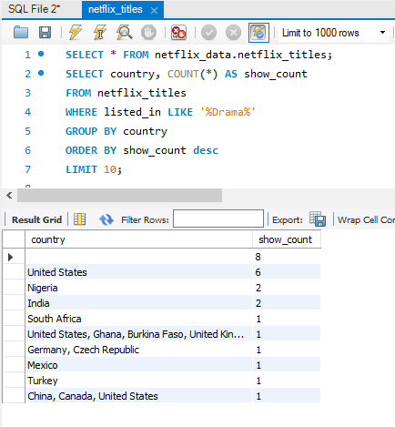

From the above result set, we see that the top 10 countries that produce tv shows/movies with the genre of drama is unknown which produces the highest show count of 8, then second is US etc. One difficulty we can observe is when more than one country created the tv drama show, for example, even though US is the second country in this list, it also appears in the 10th spot as well.

1. DATA FUN

**Finding 2 cool facts about the dataset:**

1. **Fact 1: the maximum number of seasons of tv shows is 9 seasons from the US and UK meaning they have the longest running tv shows on Netflix as seen through the query used to get this information from the dataset:**

SELECT type, duration, country, title

FROM netflix_titles

WHERE type = 'TV Show'

GROUP BY type, duration, country, title

HAVING duration = (

SELECT MAX(duration)

FROM netflix_titles

WHERE type = 'TV Show'

);

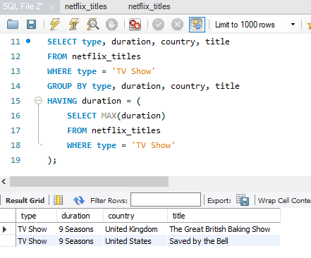

1. **Fact 2: The most common rating for Netflix shows, this will show us the typical target audience for Netflix:**

SELECT rating, COUNT(*) AS count, type

FROM netflix_titles

GROUP BY rating, type

ORDER BY count desc

LIMIT 5;

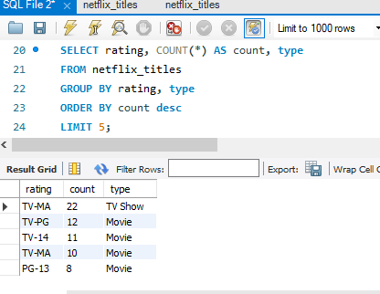

1. ASK AWAY
2. **Formulate 2 questions about the data**

* **Which year of release that had the least number of movies and tv shows.**

SELECT release_year, show_count

FROM ( SELECT release_year, COUNT(*)as show_count

FROM netflix_titles

GROUP BY release_year

) as year_counts

WHERE show_count = (

SELECT MIN(show_count)

FROM ( SELECT COUNT(*) as show_count

FROM netflix_titles

GROUP BY release_year) as min_counts

ORDER BY release_year desc

)

LIMIT 10;

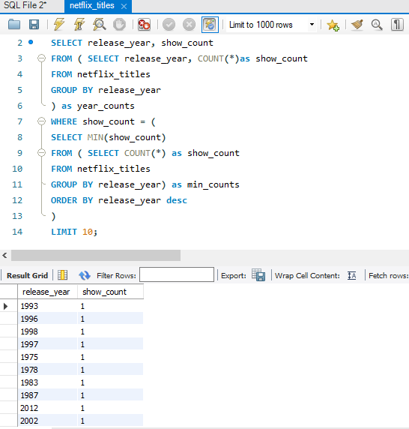

* **Which director has made the most shows/movies.**

SELECT director, COUNT(*) as show_count,type

FROM netflix_titles

WHERE director IS NOT NULL

GROUP BY director,type

ORDER BY show_count DESC

LIMIT 5;

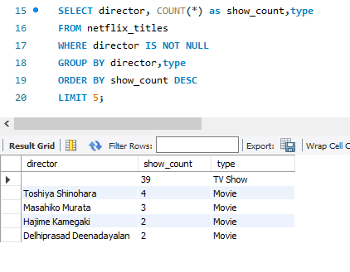

1. **Share what you learned from the answers**

From the first question, we learn that with the limit of 10, each year has a minimum of 1 movie created from each year.

From the second question, we learn that in the Netflix database the directors who have made the most tv shows/movies. Unfortunately, the director who has made the most tv shows is null.